|  |
| --- |
| **Stanton St Quintin**  **Primary & Nursery School**    **Prospectus**  *To Motivate, Educate & Nurture* |

**WELCOME**

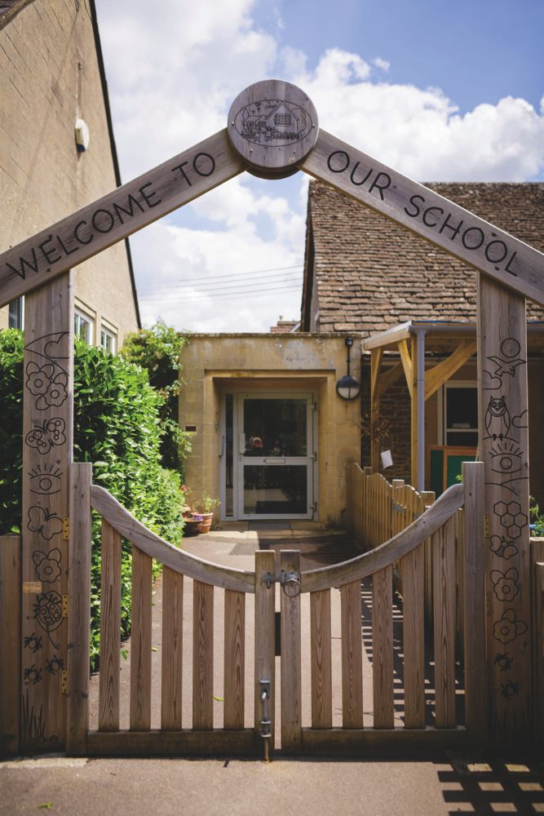

**A very warm welcome to Stanton St. Quintin Primary & Nursery School.**

**Starting school is one of the most important events in your child’s life and at Stanton we are proud of how children settle quickly and happily.**

**We are a very caring school with a strong family ethos. The happy, nurturing environment encourages children to be confident and independent. We believe in fostering a love of learning and inspiring pupils to become compassionate, kind and hardworking, enabling them to live fulfilling lives in a continuously changing world.**

**They are supported in their learning by enthusiastic and dedicated staff, governors and parents. We believe learning is a partnership where we all grow, learn and discover together.**

**NURSERY**

*Where learning and nurturing go hand in hand.*

**Age 3-4 years**

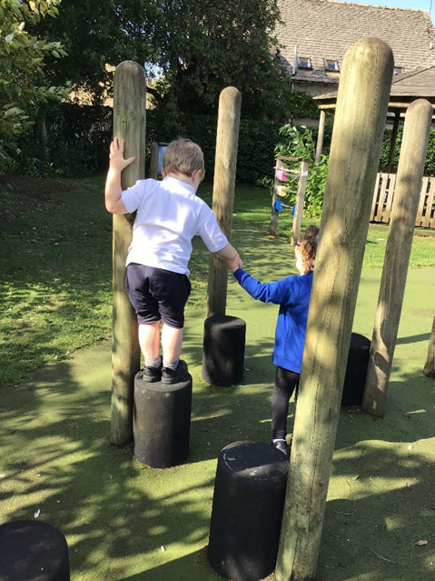

**Stanton Nursery provides your child with a very special learning environment with dedicated, experienced and enthusiastic teachers. Children have access to the school’s extensive grounds including a local woodland area. The children receive a broad range of experiences to support their learning, based around the Early Years Foundation Stage goals.**

**Children are given exciting opportunities to explore, create and play, in a safe and happy environment, which is both nurturing and fun, fostering a love of learning and school, from the very beginning.**

**Learning is individualised and children are happy and thrive. They are prepared socially and academically for the transition into reception and full time education.**

**RECEPTION**



**Beginning school is a hugely exciting milestone for both you and your child. Here at Stanton St Quintin we value the opportunity to get to know each family who choose to come to our school.**

**During the summer term, we work in partnership with every family to ensure your knowledge and understanding of your child as their primary educator is transferred to the school environment. We offer an abundance of opportunities to visit and take part in school life, including Sports Day, so that by the time September rolls around, you and your child are met by familiar faces and friends at the school gate.**

**Children benefit from being in an Early Years Setting with a well-equipped outside play area and wooded wild area within the grounds of the school. The classroom is a bright and exciting environment where children are encouraged to use their imagination.**

**We have a skills-based learning approach where purposeful planning supports each child’s next steps of development. Children learn best through play and so learning in reception is presented in fun, inspiring and motivating ways that capture the children’s interests and enthusiasm.**

**Children are encouraged to make choices, become independent thinkers, to take risks in their learning and to develop positive relationships.**

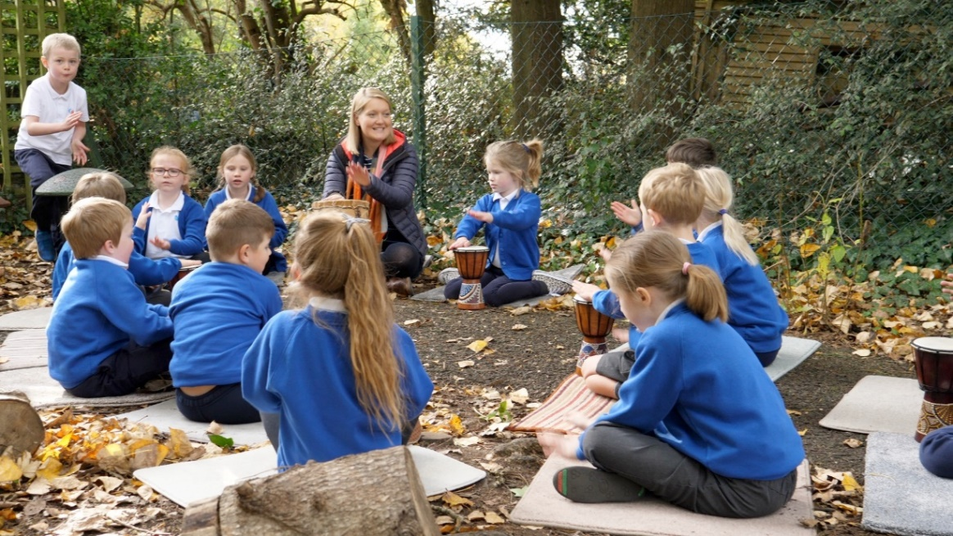**KEY STAGE 1 (Year 1 & 2)**

**Moving into a new class is an exciting time and it is important that children in Reception experience a settled and seamless transition into Year 1 at the start of the new school year. In Key Stage 1, we pride ourselves on making learning exciting and awe-inspiring whilst also meeting the developmental needs of every child across both year groups.**

**It is our passion to motivate, support and stretch your child as a writer, mathematician, scientist, artist and everything in between. We firmly believe that every child has their own individual talent to be discovered and nurtured** **during their time with us.**

**Learning to read and write is an important part of early schooling. In Key Stage 1, children take part in a daily phonics session, building on their knowledge of sounds learnt in the Early Years. We follow the engaging Sounds Write approach to teach phonics in Year 1 and 2, preparing children as fluent readers and confident spellers ready for further success in Year 3.**

**Books, storytelling and reading for pleasure is at the heart of our teaching approach, inspiring children to become more adventurous readers as they progress through Key Stage 1 and explore the wealth of wonderful literature available at Stanton.**

**KEY STAGE 2 (Year 3 - 6)**

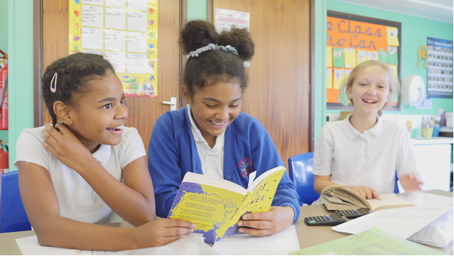

**In Key Stage 2 children continue to develop a love of learning in a nurturing and stimulating environment. Experienced staff build on your child’s existing skills and give them opportunities to apply their knowledge, analyse information, think critically, collaborate and communicate with others, as well as solve complex problems and make their own decisions.**

**There is a real emphasis on teaching strategies for solving problems so they can be equipped to deal with different situations. For example, in mathematics children are taught to interrogate problems and use different methods and approaches. Often they will use several methods and then analyse which is best and why.**

**As the children move into Upper Key Stage 2 they are motivated to take more responsibility for their own learning, behaviour and progress. They are encouraged to take an active role in their own learning and are taught to plan, monitor and evaluate their own learning. This is a valuable skill that they will carry through in their next stage of learning.**

**They will also have the opportunity to contribute to the wider school community and take on roles such as being a buddy to children in early years or house captains. These opportunities create experiences that connect students beyond the classroom and teach them the skills that are necessary for the future**

**MUSIC, DRAMA & ART**

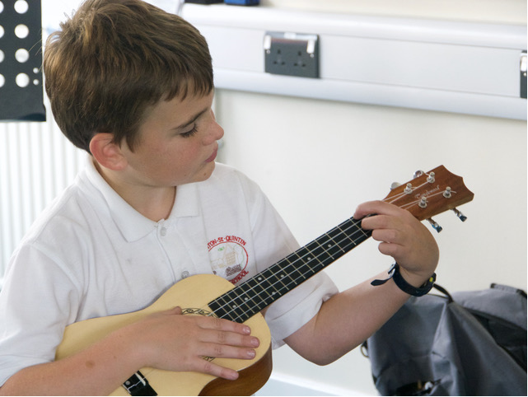

**Every child across the school has the opportunity to learn a musical instrument. In addition to this, we have a wide range of peripatetic teachers who offer individual lessons for a fee including woodwind, guitar, ukulele, drums and piano.**

**Children are able to showcase their talents throughout the year with opportunities to perform in productions to an audience. A nativity for EYFS and Key Stage 1 and a Summer Production for Key Stage 2. As well as these major events, children can participate in musical showcases, choirs including Young Voices.**

**We feel that it is important for every child to have the opportunity to learn and develop their creative skills. Children explore and develop their skills through seven main art forms; Painting, Collage, Sculpture, Drawing, Printing, Textiles and Digital Media. Whilst mastering these techniques, they will develop their ideas about artistic process and taking inspiration from great artists and artisans from around the world.**

**SPORT**

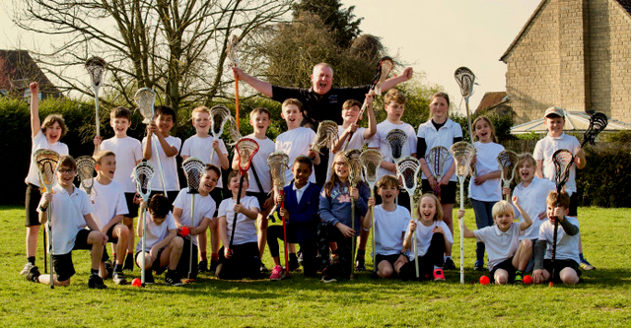

**At Stanton Physical Education is an integral part of the school curriculum.** **We encourage all our children be healthy and active and everybody takes part in sport, whatever their ability. Children have at least two PE sessions a week. These are often run by specialist coaches.**

**Our high-quality physical education curriculum inspires all pupils to succeed and excel in competitive sport and other physically demanding activities. It provides opportunities for pupils to become physically confident in a way which supports their health and fitness.**

**As part of the Chippenham Sports Partnership there is the opportunity to take part in over 40 high quality events throughout the year. We also take part in competitive games with local schools including the annual small schools football and netball tournament and the South West Lacrosse Tournament. These opportunities to compete in sport and other activities build character and help to embed values such as fairness and respect.**

**OUTDOOR LEARNING**

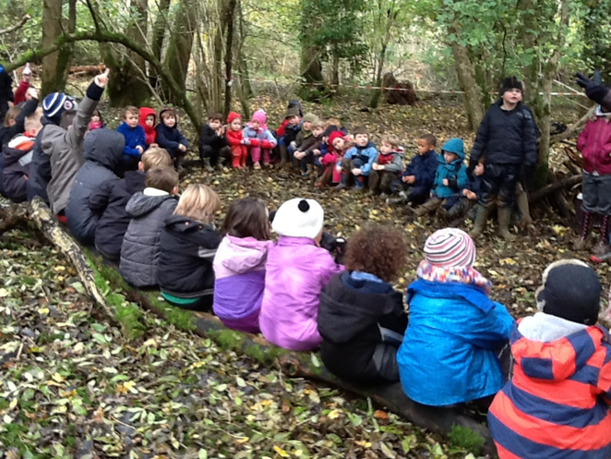

**At Stanton, we believe in taking advantage of creative learning opportunities across the curriculum.**

**This might be an outdoor maths lesson, where children apply their knowledge of number to real world situations, or a stimulating English lesson, helping children to develop their writing ideas.**

**Our woodland area provides habitat exploration for science lessons, as well as a writing stimulus for English lessons. Whatever the lesson, if using our school grounds enhances the children’s learning, we will use them.**

**We value outdoor education so much, that once a week, children in Key Stage 1 visit a local woodland.** **During our weekly visit to the woods, the outdoor environment is used to bring learning alive. Children could be using natural resources to make number patterns or using learnt strategies to calculate the age of a tree in maths. They could be using the environment for a hands on experience in science or creating a piece of art with nature. Woods learning also helps children to learn to solve problems and work as a team to find solutions. Every week is different but every visit is a rich outdoor learning experience for your child.**

**EXTRA-CURRCULAR &WRAP AROUND CARE**

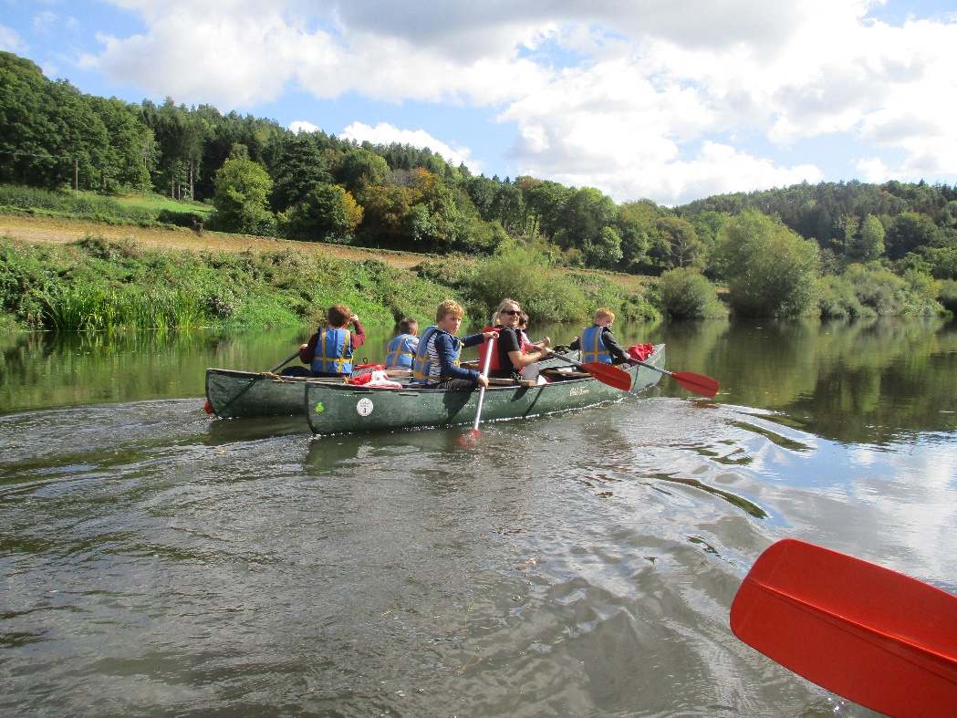

**Each class attends trips to supplement their learning. Classes will embark on visits around the local area that link with their topic. There is the opportunity to go on overnight residential trips in Key Stage 2. We also welcome visiting speakers such as authors, charities and people linked to topics, such as scientists, engineers, sportsmen and women.**

**Breakfast Club begins at 8am and after the school day finishes at 3pm, children can opt to stay for our after-school activity club which runs until 5:30pm. After school club includes an hour of sport by specialist coaches, followed by an opportunity to do homework before a light tea.**

**Over the year there are a range of clubs and activities which take place during lunchtimes and before and after school. We are extremely grateful to staff, parents, and members of the local community for running these in their own time. These have included cricket, netball, football, recorder, gymnastics and choir.**

**ADMISSIONS**

**Admissions Process**

**Step 1 – Initial Enquiry**

Please complete the Booking form online or call us to arrange a visit or book an open day event.

**Step 2 – Enquiry Response**

We will then contact you to confirm details and assist further with your enquiry and to answer any questions you might have.

**Step 3 – Enjoy a personalised tour / attend an Open Day and Evening**

You will be offered a personalised tour and/or invited to an Open Day when you can ask any questions you have and we will be able to learn a little more about what you are looking for in a school and to give you an insight into life at Stanton. This will include visiting different classrooms and the outside space, seeing learning as it happens, so that you can experience life in our happy school. The tour will be tailored according to what interests you most.

**Step 4 – Register for a place at Stanton with Wiltshire Council**

You will need to apply online at Wiltshire Council for September 2022 Intake. For in year transfers please contact the school.

[**https://www.wiltshire.gov.uk/article/1698/Applying-for-a-school-place**](https://www.wiltshire.gov.uk/article/1698/Applying-for-a-school-place)

**The closing date for Reception intake 2023 is Saturday 15th January 2023.**

**Step 5 – Offer and acceptance of a place**

The School Admissions Team will liaise with schools to make sure that, where possible, parents get a single offer for the highest preference school.

Letters are posted out to parents offering them a place at one school. Parents who apply online will be able to log back on to the online system on national offer day to view the outcome of their application. If you wish to accept the offer of a place you can do this online.

**Step 6 – Transition**

We will contact you with a welcome pack and invite you and your child to attend stay and play sessions during the summer term, which will include a woodland learning experience. This will give both you and your child the chance to become familiar with your new school environment. As well as joining Darling Class you will also be joining the whole school community and will be invited to the school Sports Day and other events such as a Summer Picnic.