World Religion Day at Stanton St Quintin
January 16th 2023

Celebrating World Religion Day
The whole school have been involved in celebrating World Religion Day.  This day unites people of all faiths and religions and celebrates their  shared values of love, kindness, respect and helping others.  Here is a little of what we got up to...  We began with a whole school assembly to think a little about what  Religion is and why it is important to learn about a little about the  different religions of the world.  In the morning, Mr Priest came in to make traditional Easter biscuits. He explained to us the link between using cassia oil and the embalming of  Jesus Christ. This activity was made all the more special as the children  were making the biscuits with their buddies.  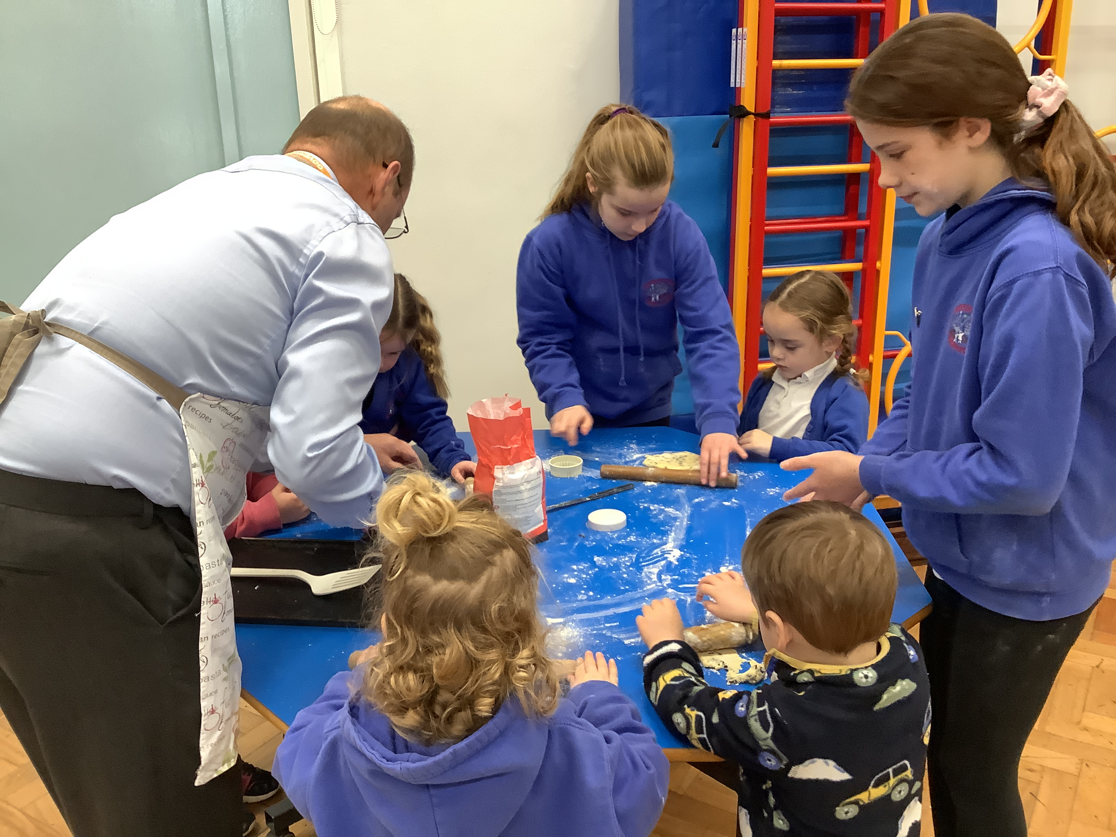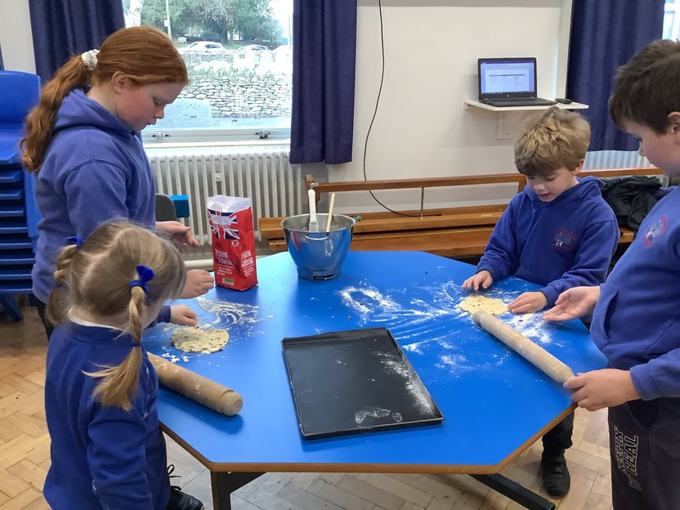  We watched Buddhists create the most amazing sand mandalas, representing the universe, and we had a go at making our own with  nature as our inspiration. | We may have different beliefs, but we all believe in love, hope, respect, kindness and forgiveness.  
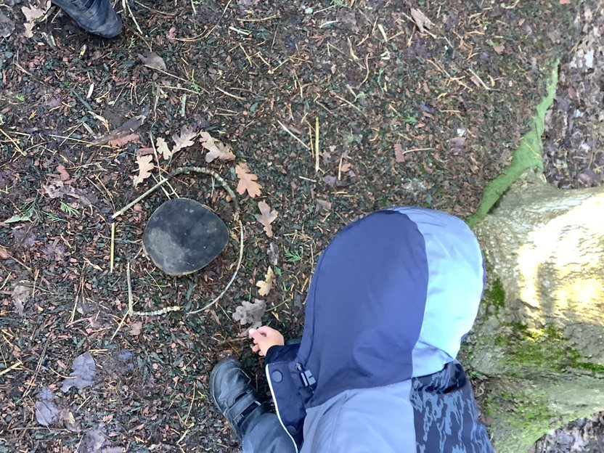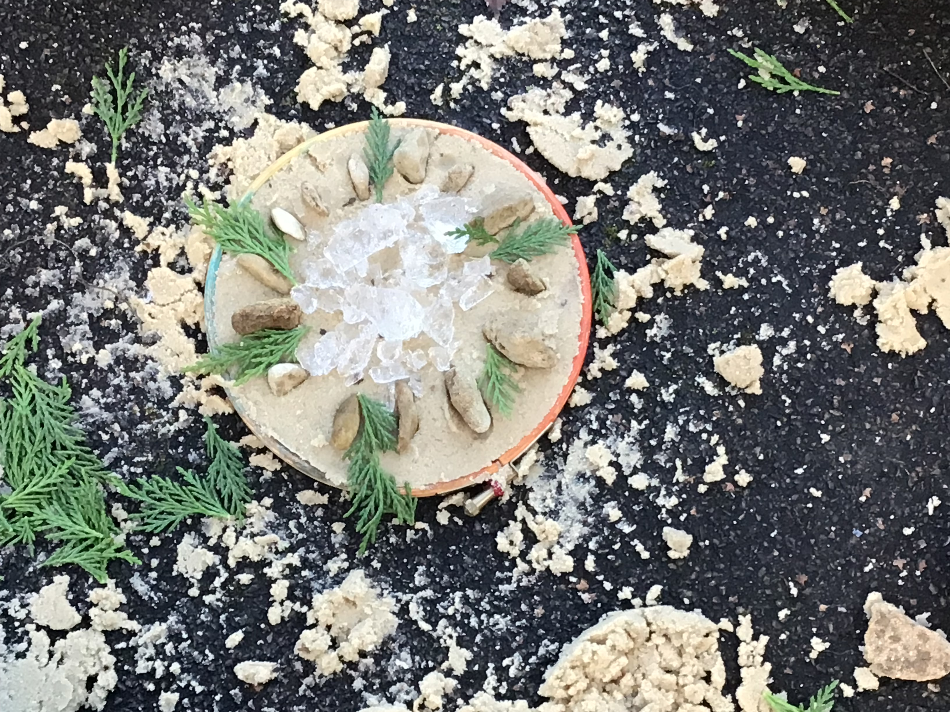
We were very fortunate to have a visit from Mrs Rai, who read the Hindu story 'Bracelets for Bina's Brothers' by Rajani LaRocca. Mrs Rai told us that Hindus make special bracelets for each other during the festival of Rahki, to tell people that you will look after them. Mrs Rai showed up how to make the bracelets and off we went!

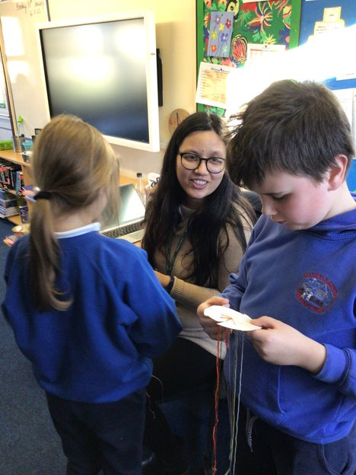
We also made our own dreidels, writing the Hebrew symbols and playing the game together. We chatted about how Jews celebrate Hanukkah and why they play the dreidel game at this time.
.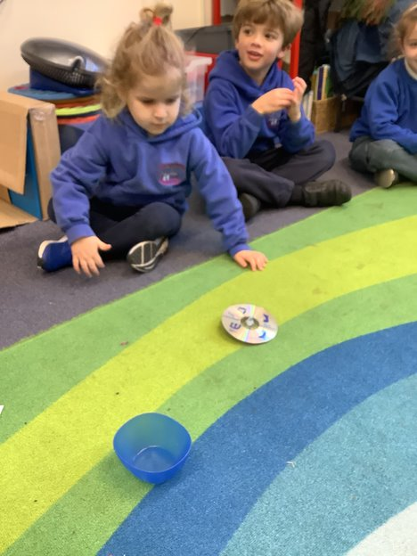 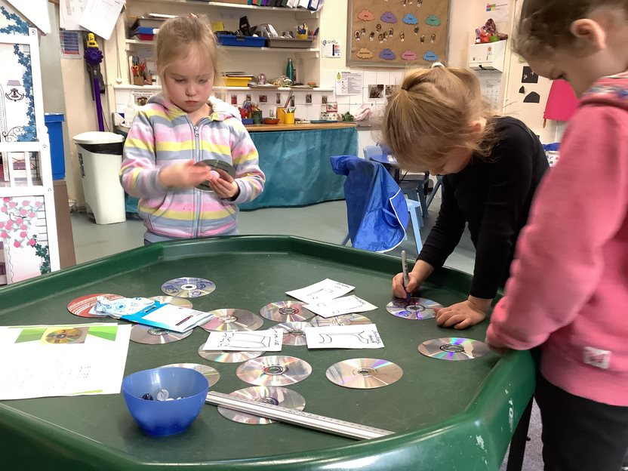
Mrs Gleed showed us the Christian baptism celebration through Godly play. We learned that in Christianity, when people are baptised, they are welcomed into the church and begin their journey with God.

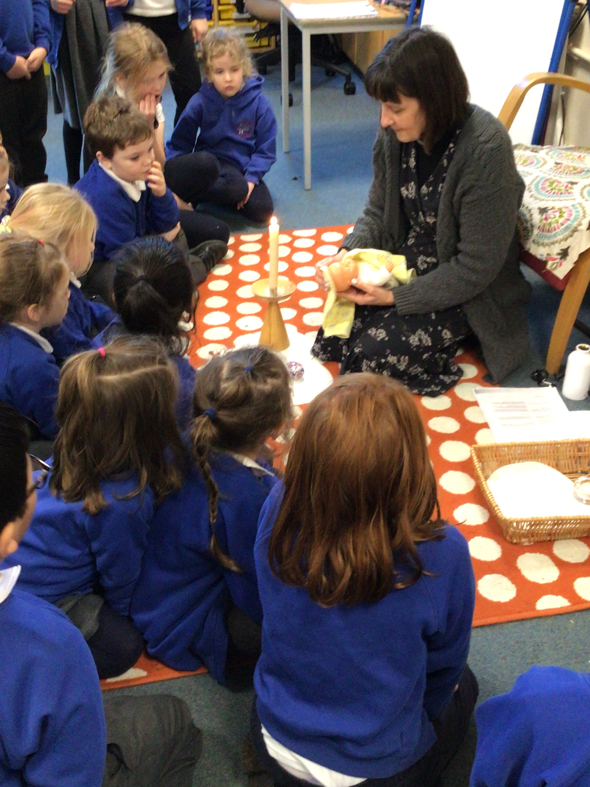

We learned all about the five K’s that are important to Sikhs and had a lot of fun learning to tie a turban!


