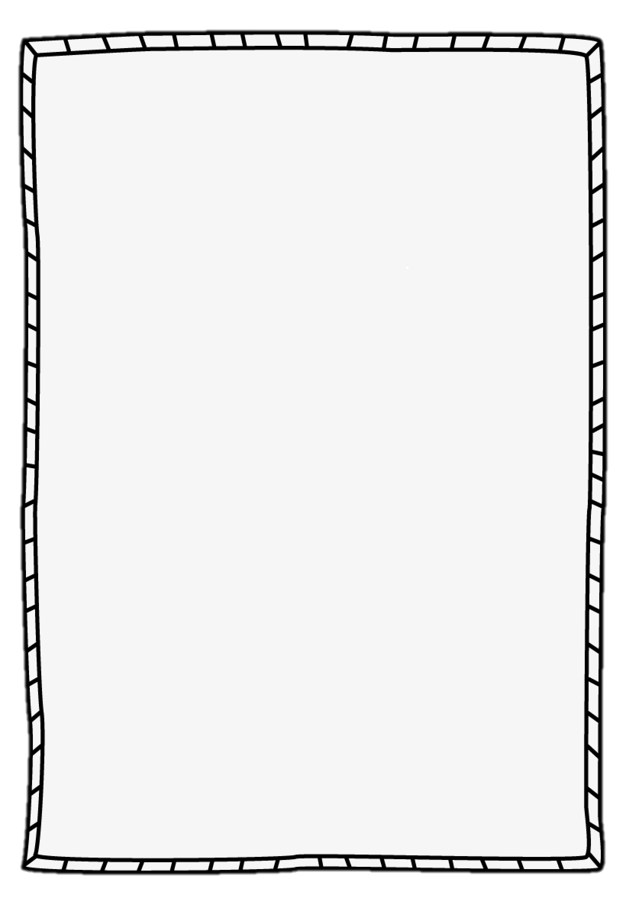
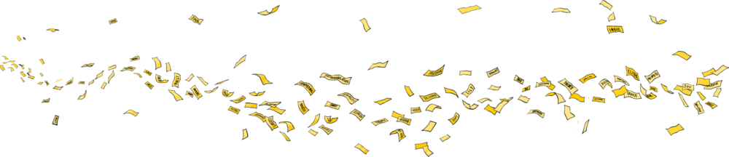
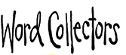
Word:
Noun, adjective, verb or adverb?
Definition:

_____________________________________

Sentence:

_____________________________________

Synonyms:
Drawing:
Word:
Noun, adjective, verb or adverb?
Definition:

_____________________________________

Sentence:

_____________________________________

Synonyms:
Drawing:

